Thursday 2-23-17
I can explain how World War I and its aftermath intensified ongoing debates about the nation’s role in the world and how best to achieve national security and pursue American interests.

I can explain how innovations in communications and technology contributed to the growth of mass culture, while significant changes occurred in internal and international migration patterns.
I can explain how popular culture grew in influence in U.S. society, even as debates increased over the effects of culture on public values, morals, and American national identity.
Agenda | Homework
1. Discuss/Review Zinn APHOTU 397-406 / American Pageant 755-760  2. Quiz Zinn Chapter 15  3. Backstory Podcast Presentation  4. Two Minute Drill (time permitting) | 1. Read!  Work on:  2. Two Minute Drill (due 2-27-17)  (see website)

Prompt 114
1. Describe the context and explain the significance of the following sources:
Source A
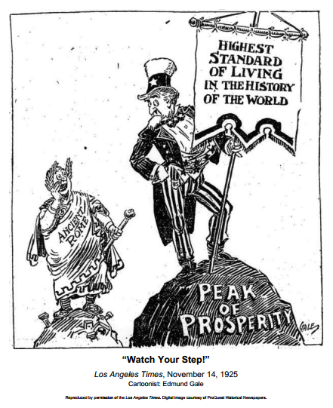

Source B & C
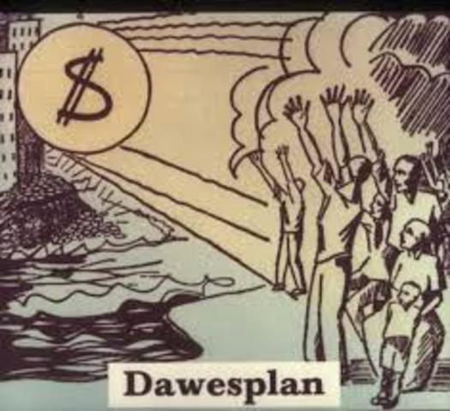 | 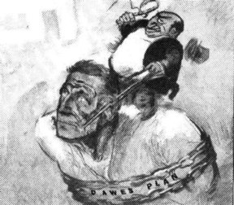

Source D
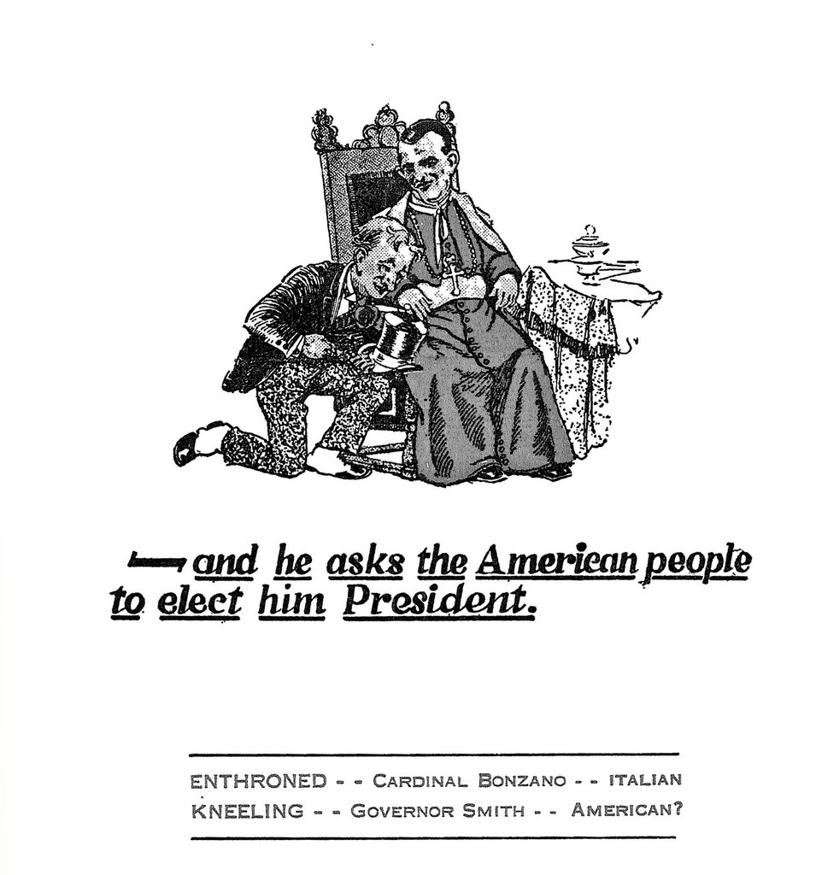

Source E
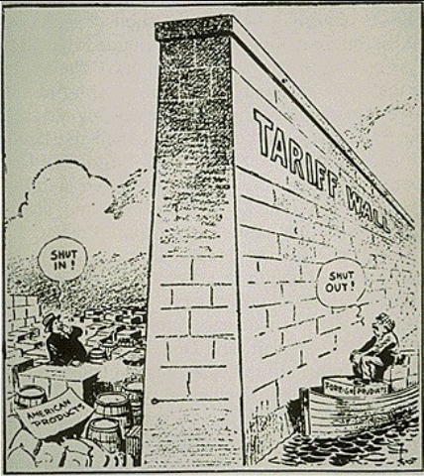
Zinn 15 Questions

1. Why did the Seattle general strike end after five days?
2. Why did the Seattle general strike symbolize to the business and government elite?
3. Why were there so many strikes after the end of World War I?
4. Why is the depiction of the 1920s as prosperous and “roaring” a misleading one?
5. Why might working class women not celebrate the passage of the Nineteenth Amendment?
6. How did Fiorella La Guardia behave differently from other political figures in the 1920s?
7. Would Alexander Hamilton have voted for the Mellon Plan? Why or Why not?
8. Why was the communist party not organized in the United States until after 1919?
9. Why did mill owners move their factories to the South in the 1920s?
10. What was Galbraith’s explanation of the American economy collapse in 1929? What was the socialist’s explanation? What was Henry Ford’s? What information, in addition to what Zinn provides, would you want to have in order to decide which theory to support?
11. What percentage of the workforce was laid off during the Great Depression? What happened to these workers?
12. What series if historical events did Steinbeck’s Grapes of Wrath chronicle?
13. What was the direct action or grassroots political activity that the hungry and homeless engaged in as a response to their condition during the depression? What was their cultural response? Their electoral response?
14. What were the demands of the Bonus Army? What was Hoover’s response to those demands? How might Hoover have handled the situation differently?
15. What evidence does Zinn use to support his argument that the New Deal legislation w
as intended “to reorganize capitalism in such a way as to overcome the crisis and stabilize the system; also, to head off the alarming growth of spontaneous rebellion. . . .”
16. Was the purpose of the Unemployment Council consistent with the structure of its organization?
17. Does Zinn believe that workers and capitalists were consciously acting according to the interests of their class?
18. Why would the AFL work hard to end the longshoremen-inspired general strike of 1934?
19. “The grave danger of the situation is that it will get completely out of the hands of the leaders.” To whom was this possibility so dangerous, and why?
20. According to Hosea Hudson, why did people want to attend block committee meetings?
21. What led to the creation of the CIO (Congress of Industrial Organizations)?
22. What were the tactical advantages of the sit-down strike over the walkout? What were the disadvantages?
23. How were the workers able to sustain the strike in Flint, MI, for three winter months?
24. Did WWII function to weaken labor’s strength in the same was the WWI did?
25. What is Langston Hughes’s argument in the section of his poem “Let America Be America Again,” quoted by Zinn?

Turn of the Century America Essay Prompts (use these as a guide)
Choose TWO of the following organizations and explain their strategies for advancing the interests of workers. To what extent were these organizations successful in achieving their objectives? Confine your answer to the period from 1875 to 1925.
Knights of Labor, American Federation of Labor, Socialist Party of America, Industrial Workers of the World
How successful was organized labor in improving the position of workers in the period from 1875 to 1900? Analyze the factors that contributed to the level of success achieved.
The period 1870 to 1900 experienced more conflict than consensus over labor relations. Assess the validity of this statement with respect to TWO of the following: Government, Industrialists, Organized Labor.
Analyze the ways in which farmers and industrial workers responded to industrialization in the Gilded Age (1865-1900).
In the post-Civil War United States, corporations grew significantly in number, size, and influence. Assess the impact of big business on the economy and politics and the responses of Americans to these changes. Confine your answer to the period 1870 to 1900.
Booker T. Washington and W. E. B. DuBois offered different strategies for dealing with the problems of poverty and discrimination faced by black Americans at the end of the 19th and beginning of the 20th centuries. Using your knowledge of the period 1877-1915, assess the appropriateness of each of these strategies in the historical context in which each was developed.
Following Reconstruction, many southern leaders promoted the idea of a “New South.” To what extent was this “New South” a reality by the time of World War I? In your answer be sure to address two of the following: Economic Development, Politics, Race Relations.
Identify and analyze the factors that changed the American city in the 2nd half of the 19th century.

What Follows?
Theodore Roosevelt was able to assert the idea of a powerful executive branch through policies such as the Hepburn Act and the Elkins Act.
…
Progressive Era Essay Prompts
Analyze the roles that women played in Progressive Era reforms from the 1880s through 1920. Focus your essay on TWO of the following: Politics, Social Conditions, Labor/Working Conditions.
Evaluate the effectiveness of the Progressive Era reformers and the federal government in bringing about reform at the national level. In your answer be sure to analyze the successes and limitations of these efforts in the period 1900-1920.
Explain how TWO of the following individuals responded to the economic and social problems created by industrialization during the late 19th and early 20th centuries. Jane Addams, Andrew Carnegie, Samuel Gompers, Upton Sinclair.
To what extent did the role of the federal government change under President Theodore Roosevelt in regard to TWO of the following: labor, trusts, conservation, world affairs.
Analyze the effectiveness of Progressive Era reformers in addressing problems of the late 19th and early 20th centuries. In your answer, focus on reform efforts in TWO of the following areas: State and federal government, the workplace, living conditions in cities.
How successful were progressive reforms during the period 1890 to 1915 with respect to TWO of the following: industrial conditions, urban life, politics?
Compare and contrast the foreign policies of Theodore Roosevelt and Woodrow Wilson.

America 1920s & 1930s Essay Prompts
Analyze the origins and outcomes of the intense cultural conflicts of the 1920s. In your response, focus on TWO of the following: Immigration, Prohibition, Religion.
How did TWO of the following help shape American national culture in the 1920s? Advertising, entertainment, mass production.
In what ways did economic conditions and development in the arts and entertainment help create the reputation of the 1920s as the Roaring Twenties?
The 1920s have been characterized as a decade of economic, social, and cultural change. Analyze the extent to which the First World War and consumerism affected United States society during this period.
To what extent did the United States achieve the objectives that led it to enter World War I?
Describe and account for the rise of nativism in American society from 1900 to 1930.
President Franklin D. Roosevelt is commonly thought of as a liberal and President Herbert Hoover as a conservative. To what extent are these characterizations valid?
Analyze the responses of Franklin D. Roosevelt’s administration to the problems of the Great Depression. How effective were these responses? How did they change the role of the federal government? Use your knowledge of the period 1929-1941 to construct your essay.
How successful were the programs of the New Deal in solving the problems of the Great Depression? Assess with respect to TWO of the following: Relief, Recovery, Reform.

Podcast Report- Part 1
1. Review the lists of podcasts from Backstory.
2. Pick three episodes you are interested in listening to, digging deeper into and reporting back to the class on.
3. Write a paragraph for each episode in which you are interested, explaining your interest.
Podcast Report – Part 2
1. Listen to your assigned podcast.
2. Take notes on your podcast.
- Base your notes on the distinct sections of the podcast
- Note the names of people interviewing and being interviewed
- What are the main points? Evidence?
- What are the connections with APUSH? (be specific look at the Curriculum Guide!)
Podcast Report – Part 3
Product: A scripted 10-15 minute presentation on your Backstory podcast
1. Create a presentation that addresses each of the show’s segments.
- Your PowerPoint/Slides should include a slide per segment.
- Each slide is limited to no more than 2 images and 10 words,
- Your presentation should explicitly include information from the “Resources” section.
- You must have a script for your presentation.
2. Presentation
- All team members must participate
- 10-15 minutes (10 minute minimum and 14 maximum)
- Poise
- Appearance
3. Generate and Model 5 historical connections based on your episode.
4. Due Monday 2-20-17
APUSH Period 7: 1890-1945
A. Growth expanded opportunity, while economic instability led to new efforts to reform U.S. society and its economic system.
B. The United States continued its transition from a rural, agricultural economy to an urban, industrial economy led by large companies.
C. In the Progressive Era of the early 20th century, Progressives responded to political corruption, economic instability, and social concerns by calling for greater government action and other political and social measures.
D. During the 1930s, policymakers responded to the mass unemployment and social upheavals of the Great Depression by transforming the U.S. into a limited welfare state, redefining the goals and ideas of modern American liberalism.
E. Innovations in communications and technology contributed to the growth of mass culture, while significant changes occurred in internal and international migration patterns.
F. Popular culture grew in influence in U.S. society, even as debates increased over the effects of culture on public values, morals, and American national identity.
G. Economic pressures, global events, and political developments caused sharp variations in the numbers, sources, and experiences of both international and internal migrants.
H. Participation in a series of global conflicts propelled the United States into a position of international power while renewing domestic debates over the nation’s proper role in the world.
I. In the late 19th century and early 20th century, new U.S. territorial ambitions and acquisitions in the Western Hemisphere and the Pacific accompanied heightened public debates over America’s role in the world.
J. World War I and its aftermath intensified ongoing debates about the nation’s role in the world and how best to achieve national security and pursue American interests.
K. U.S. participation in World War II transformed American society, while the victory of the United States and its allies over the Axis powers vaulted the U.S. into a position of global, political, and military leadership.
Reading Schedule for AP US History February & March 2017

Readings are due on the day they are listed. All pages are from the American Pageant unless otherwise noted.

W – 2/8 | AP Test #11, pt 2
Th – 2/9 | American Pageant 696-706
F – 2/10 | American Pageant 707-719
M – 2/13 | Zinn APHOTU Chapter 14 “War is the Health of the State” – Part 1  Up to “The newspapers helped create an atmosphere of fear for possible opponents of the war.”
T – 2/14 | Zinn APHOTU Chapter 14 “War is the Health of the State” – Finish
W – 2/15 | Review
Th – 2/16 | APUSH Test #12 (30)
F – 2/17 | American Pageant 720-732
M - 2/20 | American Pageant 732-745
T – 2/21 | Zinn APHOTU 377-387 / American Pageant 746-750  Historical Playing Cards due
W – 2/22 | Zinn APHOTU 387-397 / American Pageant 751-755
Th – 2/23 | Zinn APHOTU 397-406 / American Pageant 755-760
F – 2/24 | American Pageant 760-769
M – 2/27 | Review – 2 Minute Drill Due
T – 2/28 | APUSH Test #13 (31-32)
W – 3/1 | American Pageant 770-778
Th – 3/2 | American Pageant 778-791
F – 3/3 | American Pageant 792-799
M – 3/6 | Review/Essay Workshop
T – 3/7 | Review/Essay Workshop
W – 3/8 | Test #14 (33 and parts of 31&32)
Th – 3/9 | AP 800 - 820 (chapter 34)
F – 3/10 | AP 821 – 828
M – 3/13 | AP 828 - 838
T – 3/14 | AP 838 – 849
W – 3/15 | Review / Essay Workshop
Th – 3/16 | Review / Essay Workshop
F – 3/17 | Test #15 (34-35) – END of Grading Period

Enrichment Ticket

Step 1
- Create a trading game card (Hearthstone, Pokemon, Magic, etc.) based on a historical person from AP chapters 23-29
- Print a color copy of your card, this is your ticket to move on to step 2
- Write up an explanation of the character’s traits to history

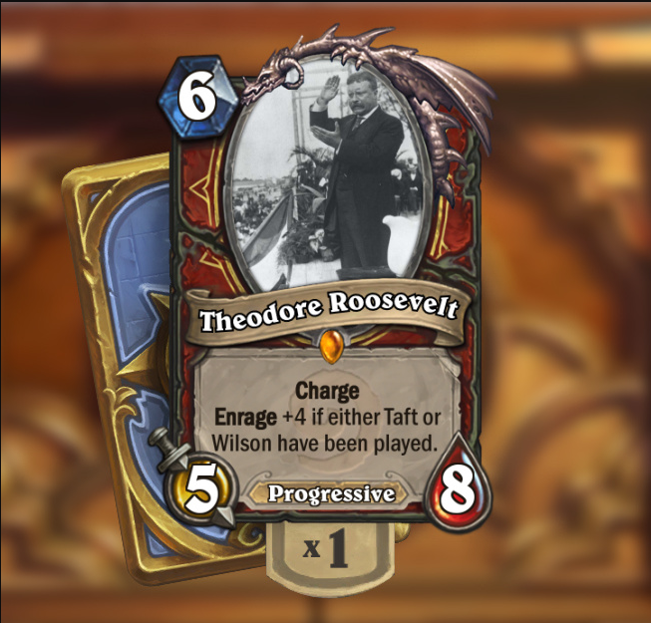

Step 2
- Your will be able to recover test points by taking an assessment
- The assessment will contain Simple IDs from AP chapters 23-25
- The assessment will require you to write a Long Essay from AP chapters 23-25

Use these as a guide for Simple IDs
Credit Mobilier – Whiskey Ring  Tammany Hall – Pendleton Act  Panic of 1873 – panic of 1893  Election of 1876 – Reconstruction  Plessy v. Ferguson – Jim Crow  US v. Wong – 14th Amendment  Grover Cleveland – laissez-faire  Populists (Tom Watson) – Jim Crow  Wilson-Gorman tariff – McKinley tariff  Gold – Silver  Union Pacific Railroad – Central Pacific Railroad  James J. Hill – Cornelius Vanderbilt  Interstate Commerce Act – Sherman Anti-trust Act  Alexander Graham Bell – Thomas Edison  Carnegie – Rockefeller (think Captains of Industry or Robber Barons)  Henry W. Grady – James B. Duke  Gibson Girl – Francis Benjamin Johnston | Lockout – black list  Knights of Labor - American Federation of Labor  Bessemer Process – Elevator  Tammany Hall – Hull House  “social Darwinism” – “social gospel”  Booker T. Washington – W.E.B. DuBois  Charles Darwin – Louis Agassiz  Know-Nothings – American Protective Association  Joseph Pulitzer – William Randolph Hearst  Henry George – Edward Bellamy  Ben Hur – Uncle Tom’s Cabin  Mark Twain – James Fenimore Cooper  Victoria Woodhull – Anthony Comstock  Elizabeth Cady Stanton – Carrie Chapman Catt  Carrie Chapman Catt – Charlotte Perkins Gilman  Carrie Chapman Catt – Carrie A. Nation

