Friday 4-12-19
I can explain how new movements for civil rights and liberal efforts to expand the role of government generated a range of political and cultural responses.
I can explain how new demographic and social developments, along with anxieties over the Cold War, changed U.S. culture and led to significant political and moral debates that sharply divided the nation.
Agenda | Homework
1. Quiz on AP 38  2. Review AP Reading 938 – 952  3. Investigation  4. The Backstory Review Project | 1. AP 952 – 965  GL Reading: The Civil Rights Movement  2. Work on Backstory Project

Prompt 140
Describe the CONTEXT and explain the SIGNIFICANCE of the following document:
Doc 1
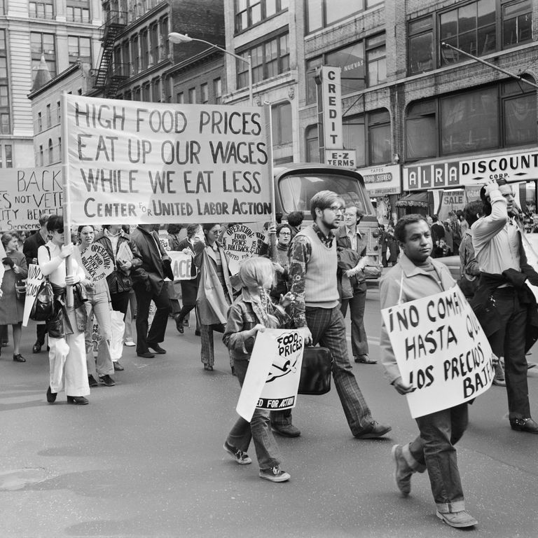

Investigation: Cambodia, Kent State and Jackson State
Read the Open Letter from J. Edgar Hoover
1. What is his overall purpose in writing this letter?
2. What are some specific tactics he identifies as used by “radical extremists?”
3. How do the following documents help contextualize and qualify Hoover’s letter?

Doc 1
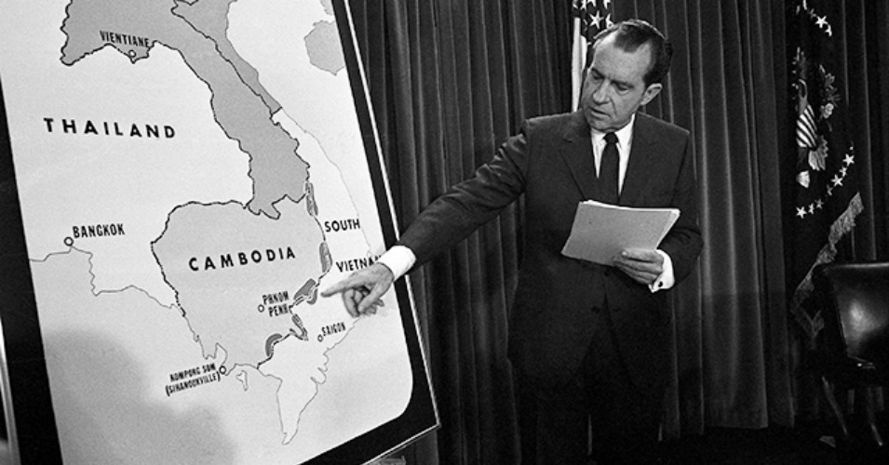

Doc 2
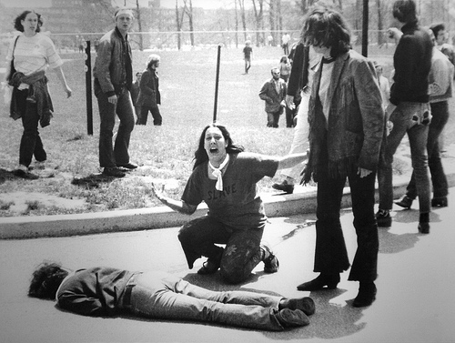

Doc 3
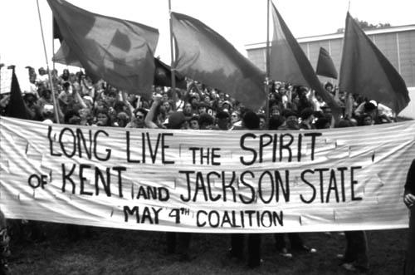

Past College Board Essay Prompts
A. Explain the causes of the rise of a women’s rights movement in the period 1940-1975.

B. Between 1954 and 1975 various groups in the United States engaged in protest. Analyze the reasons that protest emerged in this period for TWO of the following groups:
African-Americans
college students
Latino Americans
women.

C. Analyze the extent to which TWO of the following transformed American society in the 1960s and 1970s:
civil rights movement
antiwar movement
women’s movement.

D. In what ways did the administration of President Lyndon B. Johnson respond to the political, economic, and social problems of the United States?
Assess the effectiveness of these responses.
Use your knowledge of the period 1960-1970 to construct your response.

E. Discuss, with respect to TWO of the following, the view that the 1960s represented a period of profound cultural change.
Education
Gender Roles
Music
Race Relations

F. Analyze the ways in which the Vietnam War heightened social, political, and economic tensions in the United States.
Focus your answer on the period 1964 to 1975.

G. Analyze the international and domestic challenges the United States faced between 1968 and 1974, and evaluate how President Richard Nixon’s administration responded to them.

H. Analyze the ways in which the events and trends of the 1970s diminished the nation’s economic power and international influence, and challenged Americans’ confidence in both.

I. Analyze the successes and failures of the United States Cold War policy of containment as it developed in TWO of the following regions in the world during the period 1945-1975:
East and Southeast Asia
Europe
Latin America
Middle East.

J. Assess the success of the United States policy of containment in Asia between 1945 and 1975.

K. Analyze the effects of the Vietnam War on TWO of the following in the United States in the period from 1961 to 1975:
the presidency
the population between 18 and 35 years old
Cold War diplomacy.

L. Describe and account for the changes in the American presidency between 1960 and 1975, as symbolized by Kennedy’s “Camelot”, Johnson’s Great Society, and Nixon’s Watergate.
In your answer, address the powers of the presidency and the role of the media.

M. “Between 1960 and 1975, there was great progress in the struggle for political and social equality.”
Assess the validity of this statement with respect to TWO of the following groups during that period:
African Americans
Asian Americans
Latinos
Native Americans
women.

N. Analyze the ways in which TWO of the following contributed to the changes in women’s lives in the United States in the mid-twentieth century.
Wars
literature and/or popular culture
medical and/or technological advances.

O. “Landslide presidential victories do not ensure continued political effectiveness or legislative success.” Assess the validity of this statement by comparing TWO of the following presidential administrations.
Franklin Roosevelt (1936)
Lyndon Johnson (1964)
Richard Nixon (1972)
Ronald Reagan (1984)

P. Compare and contrast the Cold War foreign policies of TWO of the following presidents:
Harry Truman
Dwight Eisenhower
Richard Nixon.

Q. Explain the causes and consequences of TWO of the following population movements in the United States during the period 1945-1985:
Suburbanization
Growth of the Sun Belt
Immigration to the United States

R. How did the African American civil rights movement of the 1950s and 1960s address the failures of Reconstruction?

S. Explain the origins of TWO of the following third parties and evaluate their impact on United States politics and national policies.
The People’s Party (Populists)1892
The Progressive Party (Bull Moose Party), 1912
The States’ Rights Party (Dixiecrats), 1948
The American Independent Party, 1968

T. Describe the patterns of immigration in TWO of the periods listed below.
Compare and contrast the responses of Americans to immigrants in these periods: 1820 to 1860
1880 to 1924
1965 to 2000.

U. Presidential elections between 1928 and 1948 revealed major shifts in political party loyalties. Analyze both the reasons for these changes and their consequences during this period.

V. African American leaders have responded to racial discrimination in the United States in a variety of ways.
Compare and contrast the goals and strategies of African American leaders in the 1890s –1920s with the goals and strategies of African American leaders in the 1950s –1960s.

W. Analyze the ways in which TWO of the following shaped American politics after the 2nd World War:
anticommunism in the 1940s and 1950s
the women’s liberation movement
the ‘silent majority’ in the 1970s.

X. Explain the reasons why a new conservatism rose to prominence in the United States between 1960 and 1989.

Y. Explain the social, economic, and foreign policy goals of New Right conservatives from the 1960s to the 1980s and assess the degree to which the Reagan administration succeeded in implementing these goals in the 1980s.

Z. How and why did the goals of United States foreign policy change from the end of the First World War to the end of the Korean War?
Questions on Miss Buchanan's Period of Adjustment

APUSH Period 8: 1945-1980
A. The United States responded to an uncertain and unstable postwar world by asserting and working to maintain a position of global leadership, with far-reaching domestic and international consequences.
B. United States policymakers engaged in a Cold War with the authoritarian Soviet Union, seeking to limit the growth of Communist military power and ideological influence, create a free-market global economy, and build an international security system.
C. Cold War policies led to public debates over the power of the federal government and acceptable means for pursuing international and domestic goals while protecting civil liberties.
D. New movements for civil rights and liberal efforts to expand the role of government generated a range of political and cultural responses.
E. Seeking to fulfill Reconstruction-era promises, civil rights activists and political leaders achieved some legal and political successes in ending segregation, although progress toward racial equality was slow.
F. Responding to social conditions and the African American civil rights movement, a variety of movements emerged that focused on issues of identity, social justice, and the environment.
G. Liberalism influenced postwar politics and court decisions, but it came under increasing attack from the left as well as from a resurgent conservative movement.
H. Postwar economic and demographic changes had far-reaching consequences for American society, politics, and culture.
I. Rapid economic and social changes in American society fostered a sense of optimism in the postwar years.
J. New demographic and social developments, along with anxieties over the Cold War, changed U.S. culture and led to significant political and moral debates that sharply divided the nation.

Period 9: 1980 to the Present

A. A newly ascendant conservative movement achieved several political and policy goals during the 1980s and continued to strongly influence public discourse in the following decades.

B. Conservative beliefs regarding the need for traditional social values and a reduced role for government advanced in U.S. politics after 1980.

C. Moving into the 21st century, the nation experienced significant technological, economic, and demographic changes.

D. New developments in science and technology enhanced the economy and transformed society, while manufacturing decreased.

E. The U.S. population continued to undergo demographic shifts that had significant cultural and political consequences.

F. The end of the Cold War and new challenges to U.S. leadership forced the nation to redefine its foreign policy and role in the world.

G. The Reagan administration promoted an interventionist foreign policy that continued in later administrations, even after the end of the Cold War.

H. Following the attacks of September 11, 2001, U.S. foreign policy efforts focused on fighting terrorism around the world.

Reading Schedule for 2019
3/18 – M | AMSCO Chapters 12-15
3/19 – T | American Pageant 800 - 810 (chapter 34)  GL Reading: The New Deal
3/20 – W | American Pageant 810 - 820
3/21 – Th | American Pageant 821 – 835 (chapter 35)
3/22 – F | Mandated Workday
3/25 – M | American Pageant 835 - 849
3/26 – T | AMSCO Chapters 25-26  Review / Essay Workshop
3/27 – W | AMSCO Chapter 27  Review / Essay Workshop
3/28 – Th | AP 850 – 866
3/29 – F | Test #14 (34-35)
4/1 – M | AP 866 – 881 (chapter 36)
4/2 – T | AP 882 – 890  The Cold War: Crash Course US History #37
4/3 – W | AP 890 – 897  GL Reading: The Korean War
4/4 – Th | AP 897 – 908 (chapter 37)  The Cold War in Asia: Crash Course US History #38
4/5 – F | AMSCO Chapters 20-21
4/8 – M | AMSCO Chapters 22-24  GL Reading: The Fifties
4/9 – T | Test #15 (36-37)
4/10 – W | AP 909 – 924
4/11 – Th | AP 924 – 937 (chapter 38)  Civil Rights and the 1950s: Crash Course US History #39
4/12 – F | AP 938 – 952  The 1960s in America: Crash Course US History #40
4/15 – M | AP 952 – 965 (chapter 39)  GL Reading: The Civil Rights Movement
4/16 – T | AP 966-979 (chapter 40)
4/17 – W | AP 979-988 (chapter 40)
4/18 – Th | AP 989-998 (chapter 41)
4/19 – F | Holiday
4/22 – M | Workday
4/23 – T | AMSCO Chapters 28-31
4/24 – W | Test #16 (38-41)
4/25 – Th | AMSCO Chapters 16-17
4/26 – F | AMSCO Chapters 18-19
4/29 – M | APUSH Final Exam, Part 1
4/30 – T | APUSH Final Exam, Part 2
5/1 – W | Teacher Workday
5/2 – Th | APUSH Review
5/3 – F | APUSH Review
5/6 – M | APUSH Review
5/7 – T | APUSH Review
5/8 – W | APUSH Review
5/9 – Th | APUSH Review
5/10 – F | APUSH Exam (Starts 8am)

