Tuesday 12-6-16
I can explain how the Gilded Age produced new:
a. cultural and intellectual movements,
b. public reform efforts, and
c. political debates over economic and social policies.

I can explain how dramatic social changes in this period inspired political debates over:
a. citizenship,
b. corruption, and
c. the proper relationship between business and government.

Agenda | Homework
1. Review Reading American Pageant 502-515 (Ch 23)  2. History Puzzles  3. Chronology  4. Midterm Review | 1. Keep up with the reading schedule changes  12/6 502-515 *** 12/7 515-529  12/8 530-544 *** 12/9 544-557  2. Documentary Assignment due by 8am on 12/19

Prompt 78
1. Explain how each of the following could be a “turning point” in the American Civil War:
A. Antietam | B. Gettysburg | C. Vicksburg

2. Explain how each of the following political cartoons relates to your reading of chapter 23.

A.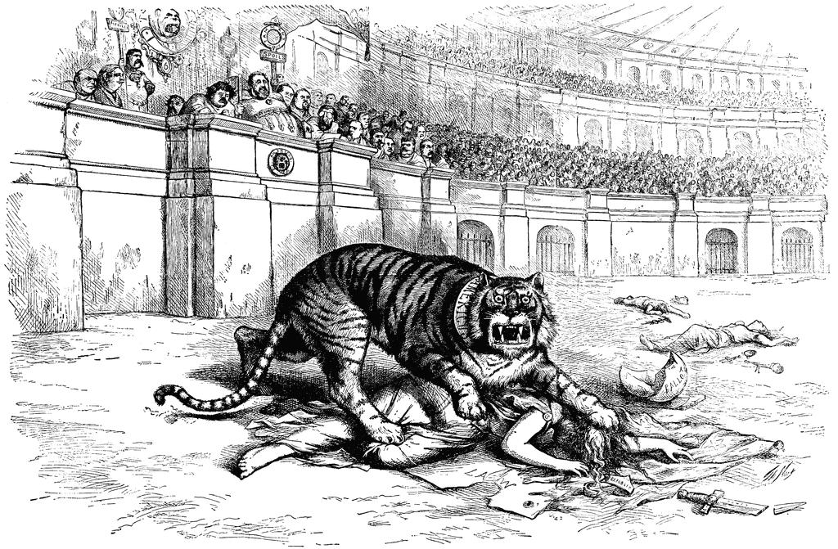

B.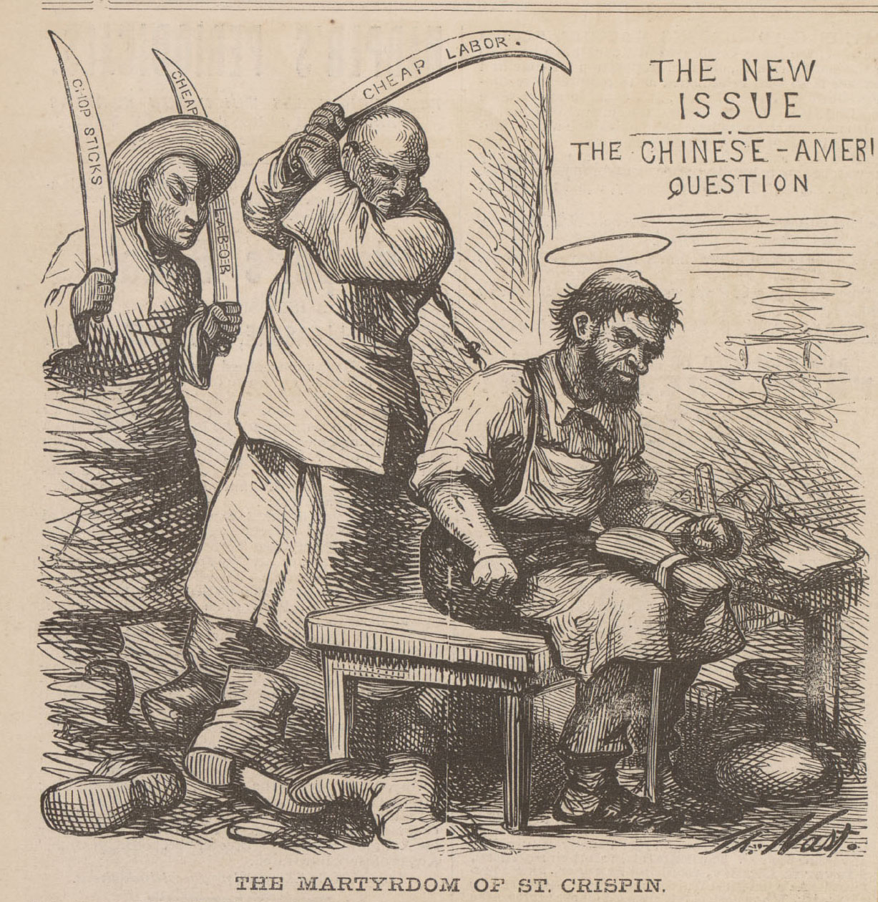
C. 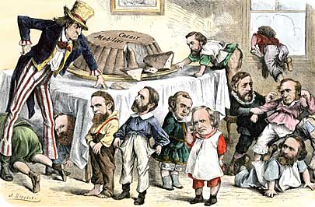
D. 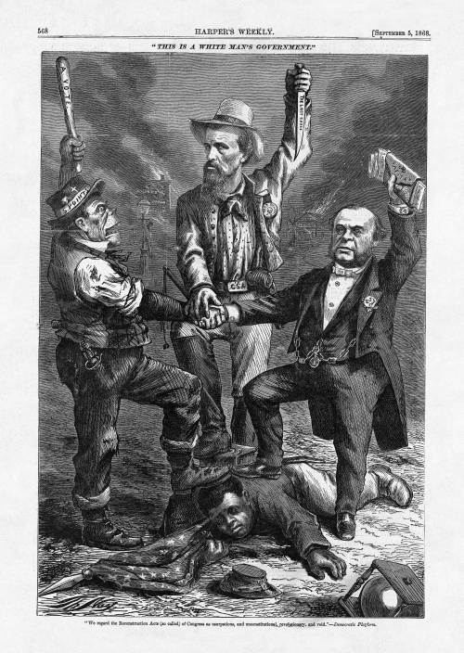
APUSH Chapter 23: Political Paralysis in the Gilded Age, 1869-1896
Thesis?
Political Paralysis?
Gilded?
Story #1 “US Grant: Good General, Bad President”
Election of 1868: “Bloody Shirts” and the “Ohio Plan”
Era of Good Stealings: Fisk & Gould – Tammany Hall (Boss Tweed) – the Dent family – Credit Mobilier – Whiskey Ring – Indian Ring

Election of 1872: Revolt of the Liberal Republicans
Grant v. Horace Greeley and the Democrats

Panic of 1873 (over-speculation, Civil War)
Creditors (Hard money) v. Debtors (Soft Money): “Crime of ’73 and the Resumption Act
1878 = Greenback Labor party (foreshadowing of the Populists)

Big Question: With so much graft and corruption, why were the races between the Democrats and Republicans so close?
Ethnic & Cultural Differences: Immigrants
Railroad Strike of 1877 – Chinese immigrants – Denis Kearney – Chinese Exclusion Act
Race: the South
Election of 1876: “The Compromise of 1877”
Civil Rights, Ha! (Civil Rights Act of 1875 – Civil Rights of Cases, 1883)
Jim Crow South: “Redeemers” – sharecropping & tenant farming – crop lien system – Plessy v. Ferguson, 1876
Patronage: “Spoils System”
Republicans: Roscoe Conkling’s Stalwarts v. James G. Blaine’s Half-Breeds

Election of 1880: “Patronage gets Shot in the Back”
Republican, James Garfield wins – Shot! – Chester A. Arthur pursues civil service reform, Pendleton Act

Election of 1884: “Mugwumps & Mudslinging”
James G. Blaine v. Grover “the Good” Cleveland
Cleveland as President: “Though the people support the government, the government should not support the people.” (laissez-faire)
GAR! (“Charge the pork-barrel!)
Tariffs (“too much of a good thing!?”)

Election of 1888: “And a Czar will be Elected”
Cleveland v. Benjamin Harrison (“Ben, I am your father!”)
Thomas “Czar” Reed and the Billion Congress (“Czar? No, just call him Santa Claus!”)

Election of 1892: “Revolt of the Rednecks!”
Rise of the Populists (Farmers’ Alliances) – Who? – What? (Omaha Platform) – Weaknesses (Industrial Workers and Race, Tom Watson)
Cleveland wins, but runs into the depression of 1893 (Silver and Gold: Sherman Silver Purchase Act and JP Morgan)
Wilson-Gorman Tariff…Oops!

Prompt 77
Union Army Camp in 1863, Thomas Nast
1. Who is the jolly old elf handing out gifts?
2. What message(s) might Americans in the North read into this cartoon in January of 1863?
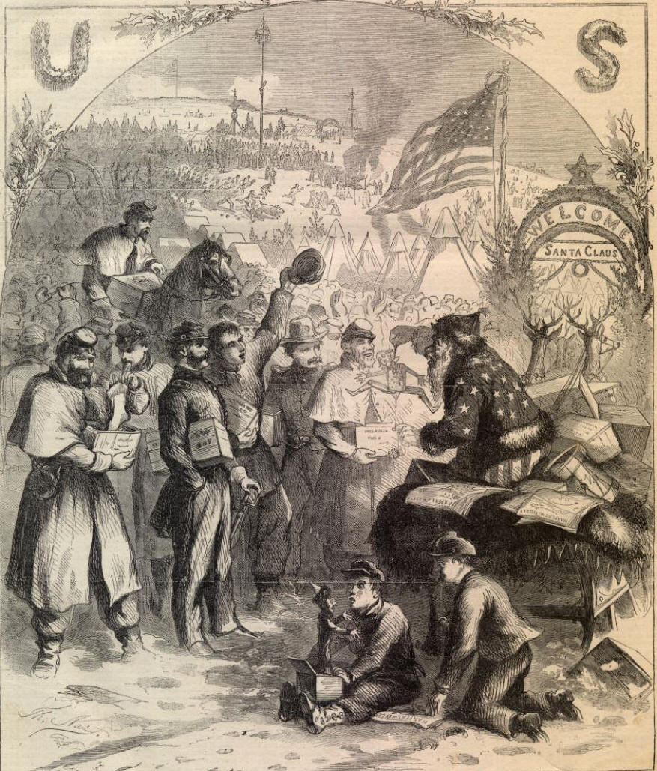
For more information, go to:
http://cartoons.osu.edu/digital_albums/thomasnast/santa_camp.htm

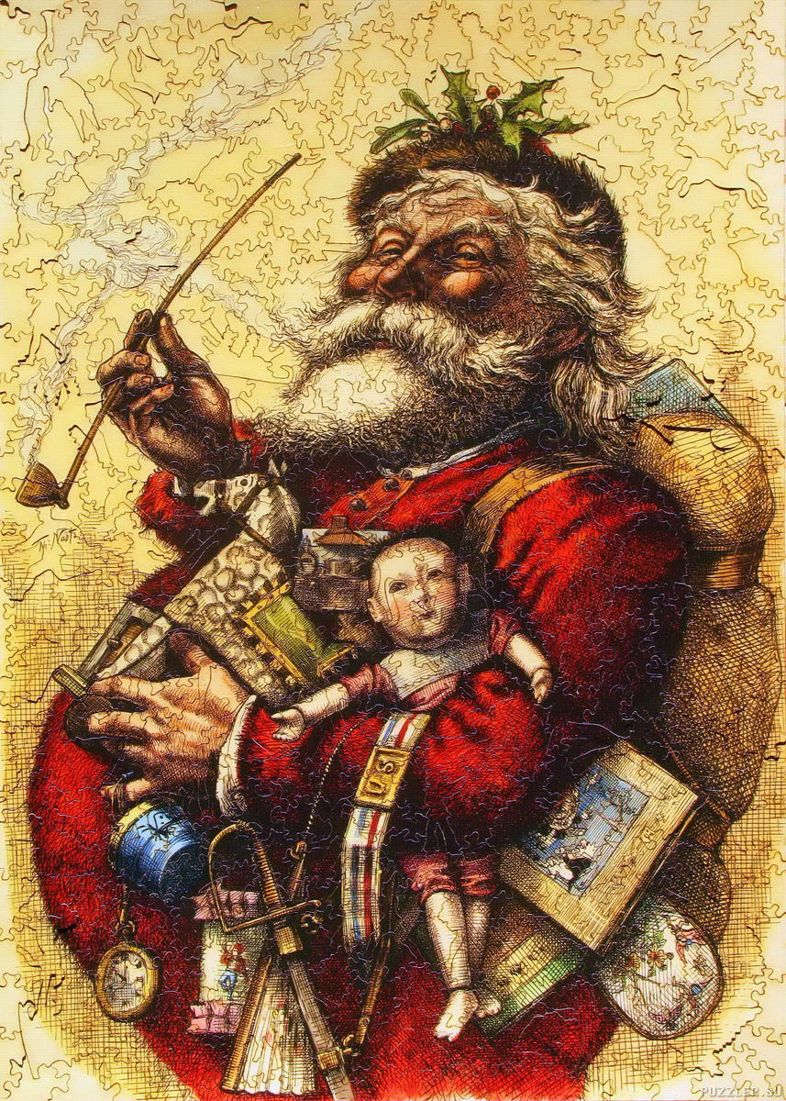

APUSH Questions/Note Ideas – Chapter 23: The Gilded Age
(504-510)
1. Thesis?
2. What was the “Bloody Shirt”?
3. What group of people was essential for Grant to win the election of 1868? Explain.
4. Who were Jim Fisk and Jay Gould?
5. Describe the following scandals: a. Credit Mobilier & b. Whiskey Ring
6. Who were the Liberal Republicans and what did they want?
7. Describe the panic of 1873.
8. Why was voter turnout so high during the Gilded Age? (p.509)
9. What was GAR?
(510-520)
10. Describe the problem that led to the Compromise of 1877.
11. Explain the Compromise of 1877.
12. What is the relationship between Jim Crow laws and the US Supreme Court case of Plessy v. Ferguson.
13. What labor movement weaknesses were revealed by the failure of the Great Railroad Strike?
14. Describe the supporters of Chinese Exclusion Act.
15. What was the ruling in the Supreme Court case of U.S. v. Wong Kim Ark? (use the terms jus soli and jus sanguinis)
16. How does Chester A. Arthur fit the pattern established by John Tyler?
17. Describe the unintended problems created by the Pendleton Act.
18. Explain the term, “pig selling.”
19. Describe the origins of “Chinatowns.”

20. Explain the issues of the 1884 Presidential Election. (The Gilded Age at its Best)
Grover Cleveland v. James G. Blaine (RRR)
Issues:

(520-529)
21. Describe the political position of President (Super) Grover Cleveland on each of the following issues:
Laissez-faire | North/South | GAR | Tariff

22. Explain the issues of the 1888 Presidential Election.
Grover Cleveland v. Benjamin Harrison
Issues:

23. Who was “Czar” Thomas B. Reed (Republican, Maine) and why was he called czar?
24. McKinley Tariff, what impact did it have on farmers? (Rural v. Urban)
25. Who were the Populists?
Platform
Farmers AND Workers?
The South?

26. Explain the issues of the 1892 Presidential Election.
Grover Cleveland v. Benjamin Harrison (v. James B. Weaver)
Issues:

27. What were the causes of the Depression of 1893, Impact?
28. Why was the Sherman Silver Purchase Act repealed? Who did this upset?
29. Who was JP Morgan and why was he important to the U.S. economy?
30. Why was the Wilson-Gorman Tariff an embarrassment for Cleveland?
31. Why was the income tax important?
32. Who were the “Forgettable Presidents” and why were they so named?
33. Trace the historiographic shifts in our understanding of the Populists:
From (1) Progressive School (Beards, Parrrington, Hicks) to (2) Richard Hofstadter to (3) Woodward & Goodwyn to (4) Ayers & McMath
APUSH Period 6: 1865-1898

A. Technological advances, large-scale production methods, and the opening of new markets encouraged the rise of industrial capitalism in the United States.

B. Large-scale industrial production — accompanied by massive technological change, expanding international communication networks, and pro-growth government policies — generated rapid economic development and business consolidation.

C. A variety of perspectives on the economy and labor developed during a time of financial panics and downturns.

D. New systems of production and transportation enabled consolidation within agriculture, which, along with periods of instability, spurred a variety of responses from farmers.

E. The migrations that accompanied industrialization transformed both urban and rural areas of the United States and caused dramatic social and cultural change.

F. International and internal migration increased urban populations and fostered the growth of a new urban culture.

G. Larger numbers of migrants moved to the West in search of land and economic opportunity, frequently provoking competition and violent conflict.

H. The Gilded Age produced new cultural and intellectual movements, public reform efforts, and political debates over economic and social policies.

I. New cultural and intellectual movements both buttressed and challenged the social order of the Gilded Age.

J. Dramatic social changes in the period inspired political debates over citizenship, corruption, and the proper relationship between business and government.

Reading Schedule for Second Quarter 2016
11/16 – W | American Pageant 434-443 (Ch 20)
11/17 – Th | American Pageant 443-452 (Ch 20)
11/18 – F | American Pageant 453-462 (Ch 21)
11/21 – M | American Pageant 462-478 (Ch 21)
11/22 – T | Zinn 10 “The Other Civil War”
11/23 to 11/25 | Thanksgiving Break
11/28 – M | American Pageant 479-490 (Ch 22)
11/29 – T | American Pageant 490-501 (Ch 22)
11/30 – W | Review
12/1 – Th | Test # 8 (20-22) End Period 5 (1844-1877)
12/2 – F
12/5 –M
12/6 – T | American Pageant 502-515 (Ch 23)
12/7 – W | American Pageant 515-529 (Ch 23)
12/8 – Th | American Pageant 530-544 (Ch 24)
12/9 - F | American Pageant 544-557 (Ch 24)
12/12 – M | First Block Exam  APUSH Exam will cover chapters 1-24 in the American Pageant  Map: 50 States  Presidents: Washington to the second coming of Cleveland
12/13 – T | Fourth Block Exam
12/14 – W | Second Block Exam
12/15 – Th | Third Block Exam
12/16 – F  End of the Grading Period | Make-up Exams  (TP Documentary is due by 8am Monday 12/19/16)
12/19/16 to 1/3/17 | Winter Break  REMEMBER!  12/19, 12/20, and 1/3 are Inclement Weather Make Up Days!
1/4/17 | American Pageant 558-572

