Quiz: Chapter Four
I. Multiple Choice

1. What did Rosa Parks do that led to a year-long boycott in Montgomery, Alabama?
A. She would not leave a lunch counter until she obtained service
B. She used a "whites only" public restroom
C. She demanded certain public school privileges for her children
D. She refused to give up her seat on a bus to another passenger

2. Which measure outlawed poll taxes?
A. Civil Rights Act of 1957 C. Voting Rights Act of 1965
B. Civil Rights Act of 1954 D. Twenty-Fourth Amendment

3. Which amendment guaranteed African American men the right to vote?
A. Thirteenth Amendment C. Fifteenth Amendment
B. Fourteenth Amendment D. Nineteenth Amendment

4. Which amendment states that all rights not spelled out in the Constitution are “retained by the people”?
A. Second Amendment C. Seventh Amendment
B. Third Amendment D. Ninth Amendment

5. Which of the following does the Bill of Rights protect?
A. the right to provoke a riot for a good cause
B. the power of government to operate efficiently
C. the freedom to act without government interference
D. the choice to overthrow an unjust government by force

6. How does the Fifth Amendment help accused persons?
A. by requiring a speedy trial C. by guaranteeing a trial by jury
B. by requiring a search warrant D. by protecting against self-incrimination

7. Whose right to vote did the Twenty-sixth Amendment guarantee?
A. poor people in the South C. residents of Washington, D.C.
B. women across the country D. citizens 18 years old and older

8. Which sphere of American life was desegregated in the 1940s?
A. schools C. armed forces
B. work places D. lunch counters

Use the following excerpt and your knowledge of Social Studies to answer question 9.
“All persons born or naturalized in the United States, and subject to the jurisdiction thereof, are citizens of the United States and of the State wherein they reside. No State shall make or enforce any law which shall abridge the privileges or immunities of citizens of the United States; nor shall any State deprive any person of life, liberty, or property, without due process of law; nor deny to any person within its jurisdiction the equal protection of the laws.”
14th Amendment, Section 1, US Constitution

9. The 14th Amendment established
A. Every US citizen born or naturalized in the US is granted equal protection under the laws
B. Suffrage for African Americans
C. Suffrage for women
D. Freedom to all enslaved persons living in America

Use the following excerpt and your knowledge of Social Studies to answer question 10-12.
We have no objection to discuss the question of equality, for we feel that the weight of argument lies wholly with us, but we wish the question of equality kept distinct from the question of rights, for the proof of the one does not determine the truth of the other. All men in this country have the same rights however they may differ in mind, body, or estate. The right is ours.
—Elizabeth Cady Stanton, “Address on Woman’s Rights,” 1848

10. Stanton says that she has no problem debating the equality of men and women because she
A. thinks that only men should have certain rights.
B. believes that she would win the argument.
C. wants to discuss both equality and rights.
D. believes that the weight of the argument lies with men.

11. Who is the “we” to whom Stanton refers?
A. civil rights leaders, both men and women
B. male political leaders
C. female political leaders
D. women who expect to have the same rights as men

12. Which of the following is a reason Stanton believes the “question of equality” should remain separate from the “question of rights”?
A. Men should have fewer rights than currently granted by law.
B. Equality has been proved, so discussions should focus on rights.
C. All men enjoy the same rights, despite inequalities among them.
D. Previous attempts at combining the two ideas were unsuccessful.

Use the following excerpt and your knowledge of Social Studies to answer question 13-15.

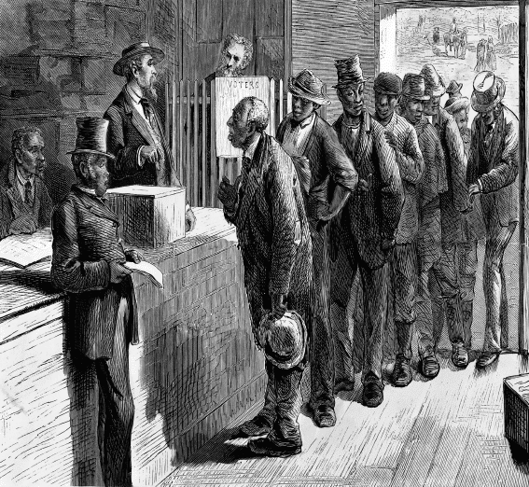

13. The African Americans depicted in the illustration above were guaranteed the right to vote by the
A. Fourteenth Amendment. C. Sixteenth Amendment.
B. Fifteenth Amendment. D. Eighteenth Amendment.

14. In the years following the Civil War, some Southern states prevented African Americans, such as those depicted in the illustration above, from voting by enacting
A. slander laws. C. poll taxes.
B. eminent domain. D. racial profiling.

15. In which order did amendments to the Constitution protect the voting rights of African Americans and the following groups?
A. women; African Americans; Washington, D.C., residents; young adults 18 and older
B. African Americans; Washington, D.C., residents; women; young adults 18 and older
C. African Americans; Washington, D.C., residents; young adults 18 and older; women
D. African Americans; women; Washington, D.C., residents; young adults 18 and older
II. Short Answer (Write in complete thoughts and complete sentences)
The Bill of Rights: For TWO of the following images, identify the Amendment represented and describe the right(s) protected.

A. 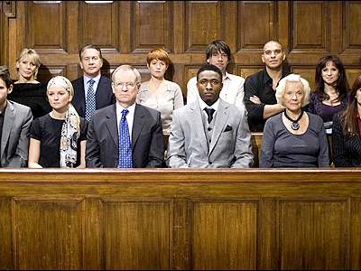
B. 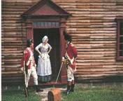
C. 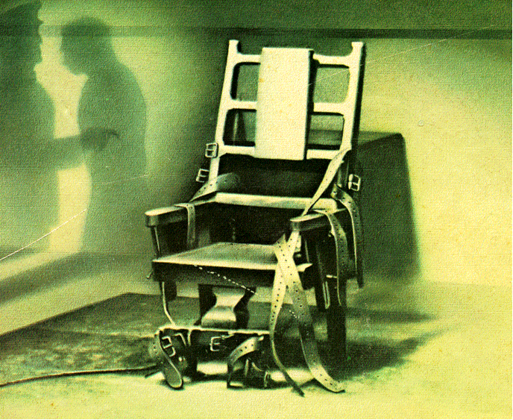
III. Short Answer (Write in complete thoughts and complete sentences)
Extending the Bill of Rights: For TWO of the following images, identify the Amendment represented and describe the right(s) protected.

D. 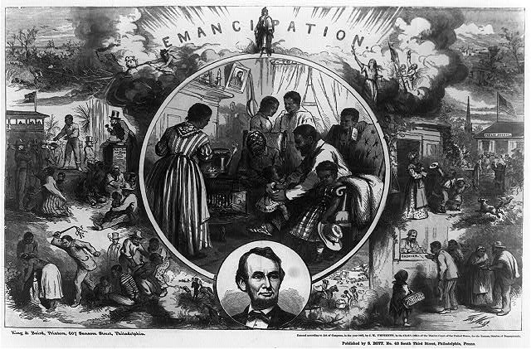
E. 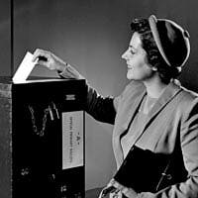
F. 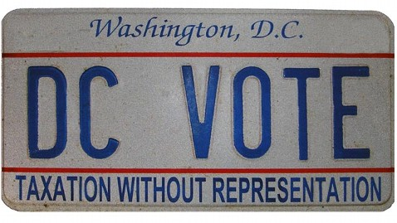

IV. Short Answer (Write in complete thoughts and complete sentences)
Civil Rights Movement: For ONE of the following images, identify what is happening (at least 3 W’s) and explain why it was important.

G. 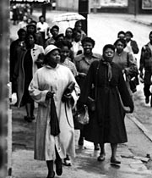
H. 